|  |
| --- |
| Reverend Jack’s |
| Admin Control Panel |
| Instruction Manual |

|  |
| --- |
| Ryan Sweitzer  11-14-2017 |

Contents

Introduction 2

Customer List 3

Product List 4

Order List 6

Order Details 7

# Introduction

The purpose of this guide is to show the user the functionality of the Admin Control panel that resides in the Reverend Jack’s Website. I will go over the controls that can be used for each function as well as the do’s and don’t of every input and button. Currently there are four main parts of the panel:

1. Customer List: This is the list of all the users that have registered to the website, this includes all the admin accounts along with customers, please ensure that when editing that you take extra precaution that you are editing the correct user
2. Product list: This list holds all the products that are being sold on the site. There is an added feature to the bottom of the list that you can add in products yourself.
3. Order list: This holds all the orders that have been made, you will have to interact with this list for every order that is made.
4. Order Details: This will display all items that pertain to every order. You will also be interacting with this for every order as well.

This guide should be pretty straight forward into how you should be interacting with this page. If there are any questions that this guide does not answer. Please direct them towards the current site manager of the website.

# Customer List

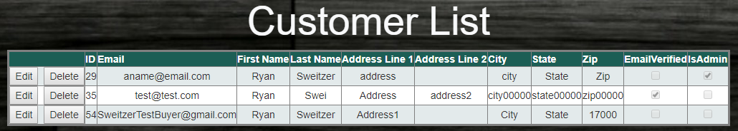

This will be the typical view of the customer list. You won’t have much to do here unless a user asks you to remove their account for any reason. If you need to remove an account, all you have to do is hit the  button. This will pop up a warning, if you click ok, it will go ahead and delete the record and cancel will cancel the delete action. If you need to change a user’s information or you need to make a specific user an admin, then you will click the  button.

This will turn the view into this:

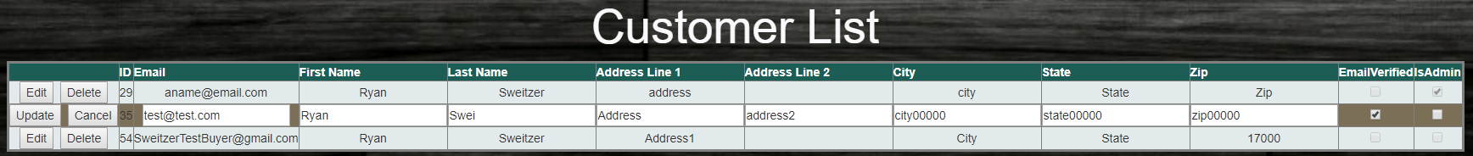

I clicked the edit button beside [test@test.com](mailto:test@test.com) and it opened the users information into editable text boxes as well as allow the check boxes at the end to be clickable. You can go ahead and manage whatever you need to. Once you’re done and you want to save the changes, you will click the  button. If you want to cancel your action, just hit the  button.

Warning! By clicking on is admin and updating the record, you are giving that user admin rights and allowing them onto this page. Do not give anyone the admin rights that do not belong on this page.

# Product List

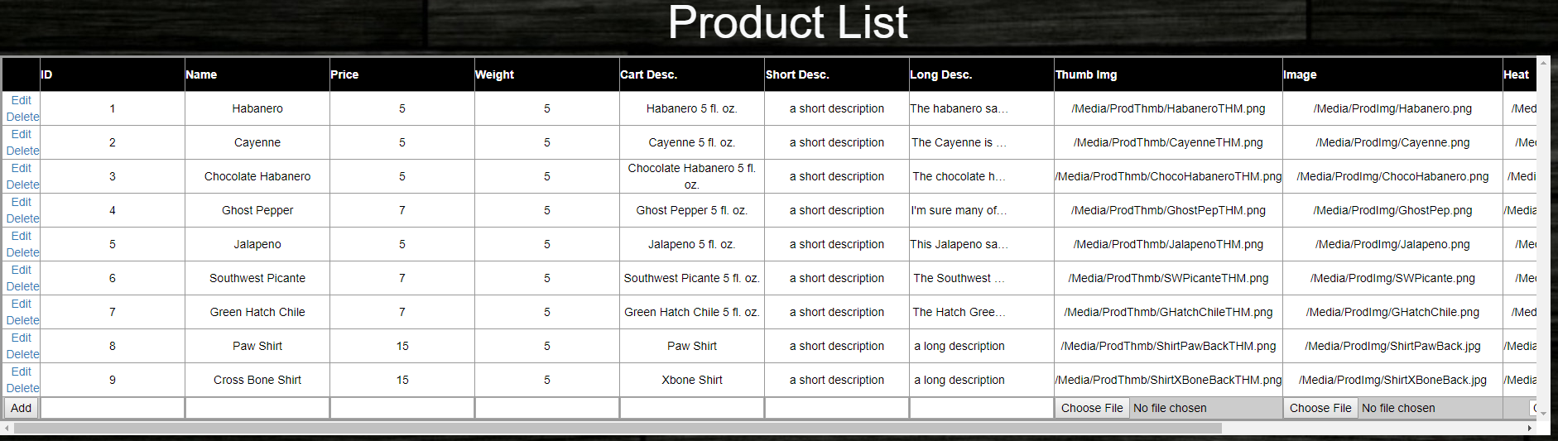

This is the list that holds all the product being sold. This is where you are going to have to watch what you enter where because a mistake can cause an error and not get the response that we need. Like the Customer list, you can edit each record as you need but you can also add new products to the list by entering the information in the bottom of the list. This is a handy way for anyone to update the inventory but there are a couple of constraints to what you can enter in which textbox. Here is a list of each field and what exactly you can or cannot enter:

1. ID: Do not change this number unless you have cleared it with the site manager. This is a unique number that identifies each product and must not match any other product.
2. Name: Name of product. No major constraints here.
3. Price & Weight: Warning! You can only enter numbers or decimals in these fields. Do not enter any text or any other special characters or it will cause an error.
4. Cart Desc., Short Desc. and Long Desc.: The cart description is what the user will see when they are looking at their item in their cart. The short description is what is viewed when the user is looking at the list of products in the products page. The Long description is what the user is looking at when looking at the product detail page where you can add the item to your cart. There are no restrictions as to what you can enter here but I would suggest to write out the descriptions first on a word document or notepad before entering it on the website
5. Thumb img. and image: This is where you can upload the image of the product you want to sell. The thumb image is what the user will see in the cart view and the image is what the user sees in the product and product display page. What you see in the existing products is the file path needed for the website to find the image and display it properly. If you want to upload the images, click  and select the correct image. Warning! When uploading a new image for a product, please ensure it is the image that matches the product. If a mistake is made, the website manager can correct the error.
6. Heat: If it’s a new sauce being added, then you can use this to select where the sauce is on the heat scale, if it is merchandise, just select XXXX.
7. Product Category: Select which category the product belongs in. it is marked for sauces, shirts, hats and decals for now, if more options needed to be added, the website manager can add them.
8. In stock: Warning! Only whole integers can be placed in this field. Right now, the website does not use this column but will in the future to report inventory counts. If adding a product to the list, enter a number more than 0.
9. Is Live: This field is not being used. Its intended purpose is to turn off a product if the stock has run out. Disregard this field for now.

# Order List



This view holds the orders that have been generated by the users. As of now, one order per user until their first order has been shipped out. This will hold the shipping information as well as how much that user should have spent and when the order was made. Once the order is filled and sent, you need to come in here and edit the record to check the field “OrderShipped”. Warning! If this does not happen, that specific user will not be able to make another order until this is done. There is an area to add a tracking number but it is not being used in the website right now but it can be added for reference if need be.

# Order Details

This is going to be what it looks like when you first open the web page:



The textbox there is for order numbers. All you type in there is the order number and I will generate all the products that belong to that specific order:

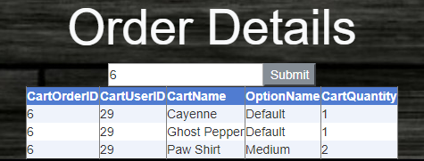

This is used to fill the specific order. The fields are as such:

1. CartOrderID: This is the number you entered to generate this table. Shows that all these products belong to the order number.
2. CartUserID: This represents the id of the user who placed the order, this can be matched to the ID number used in the customer list.
3. CartName: Name of the product being sold, its what the user chose for the order
4. OptionName: This for when the user chooses a size for a product. As of now, only shirts can have different sizes. All sauces get default since there is only one size for now.
5. CartQuantity: This represents how many of the item they ordered. If the shirt says two medium, then its two medium. If the user chooses two different size shirts, there will be separate entries for them.

If there are any questions to this guide, please direct them to either the site owner, creator or the website manager.